**I-REVOLUTION**

**SUBMITTED BY**

Team ID: NM2023TMID09131

Team members ID

1.KARTHICK.R - **6A1F84EBB7A4F4EA74C4B632675AC7CE**

(Team leader)

2.**SIVARANJITH R**  – **257443056EAB499B55041A9A7656824C**

3.MAYAN P - **3772E88FD977C09A10A4218F3B6A73F4**

4.MOGANA PRIYA R - **82C60C3D3BD7C90AB464160421D940D9**

UNDER THE GUIDANCE OF

**Dr.V.Meena ,**

**ASSISTANT PROFESSOR ,**

**Department of Mathematics,**

**Government Arts And Science College, THIRUMANGALAM ,**

**Madurai-625008**

1 INTRODUCTION

1.1 Overview

A brief description about your project

1.2 Purpose

The use of this project. What can be achieved using this.

2 Problem Definition & Design Thinking

2.1 Empathy Map

Paste the empathy map screenshot

2.2 Ideation & Brainstorming Map

Paste the Ideation & brainstorming map screenshot

3 RESULT

Final findings (Output) of the project along with screenshots.

4 ADVANTAGES & DISADVANTAGES

List of advantages and disadvantages of the proposed solution

5 APPLICATIONS

The areas where this solution can be applied

6 CONCLUSION

Conclusion summarizing the entire work and findings.

7 FUTURE SCOPE

Enhancements that can be made in the future.

8 APPENDIX

A. Source Code

Attach the code for the solution built

**1 INDRODUCTION**

* 1. **over view**

**1.** Innovation:The iPhone a breakthrough in mobile technology, introducing innovative features like a touchscreen interface.

2. Convergence: It combined a phone, iPod, and internet device, reducing the need for multiple gadgets.

3. App Ecosystem: The App Store allowed developers to create a vast array of applications, transforming how we use smartphojnes.

**1.2.purpose**

**1. Convergence of Devices: The iPhone revolutionized the concept of a smartphone by combining various devices into one, including a phone, camera, music player, and more. This convergence made it more convenient for people to carry and use multiple functions in a single device.**

**2. App Ecosystem: Apple's App Store, introduced alongside the iPhone, created a platform for developers to create and distribute mobile applications. This ecosystem led to the proliferation of apps that serve various purposes, from productivity to entertainment, fundamentally changing how we interact with technology.**

**3. User Experience and Design: The iPhone set a new standard for user-friendly design and intuitive interfaces. Its touch screen and sleek design influenced the entire mobile industry, leading to a focus on user experience and aesthetics in the development of smartphones.**

2 Problem Definition & Design Thinking

2.1 Empathy Map

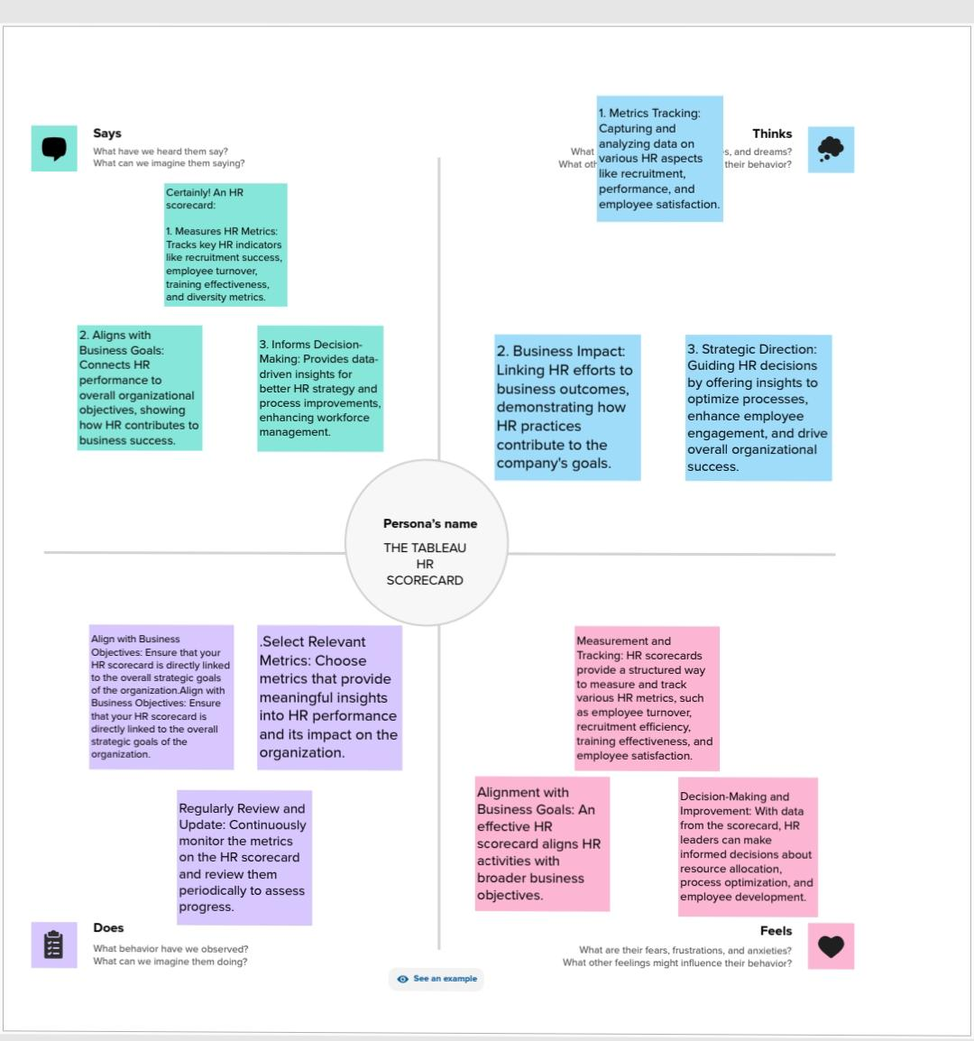

**2.2ideation and brainstorming Map**

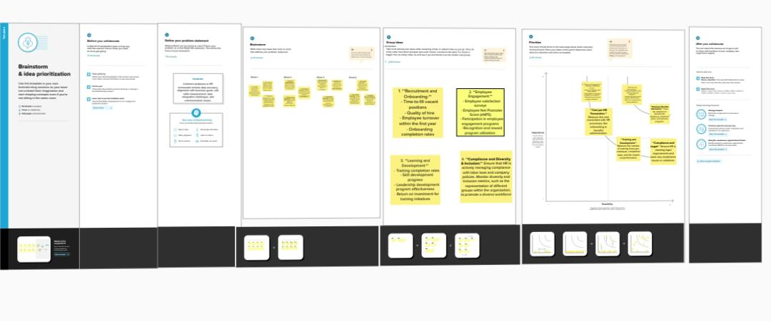

3.result

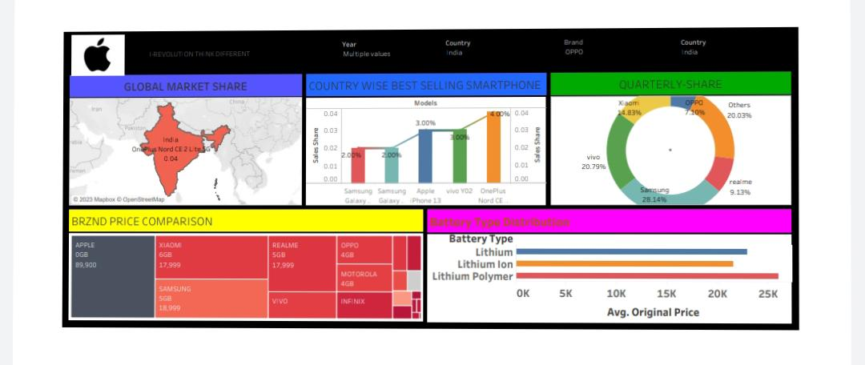Dashboard 1

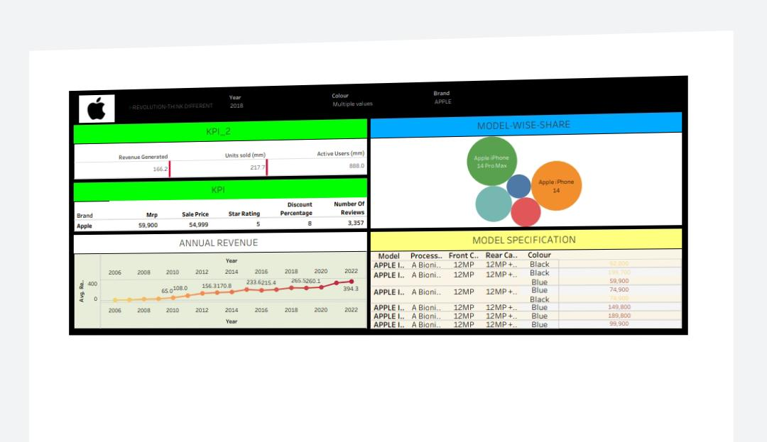Dashboard 2

**Story**

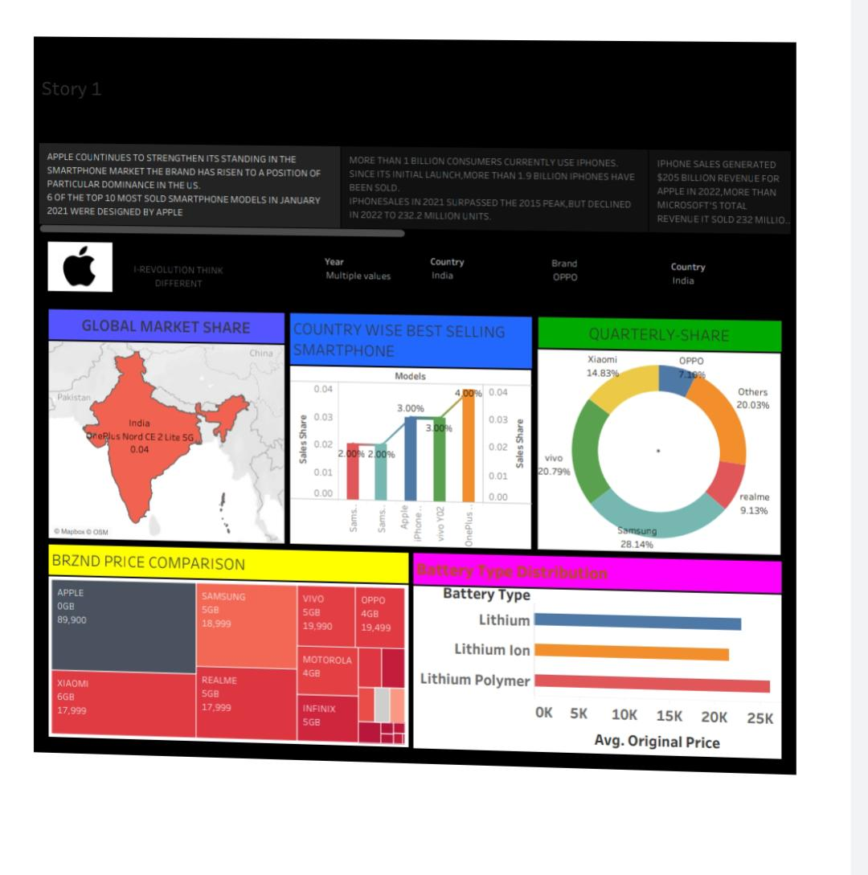

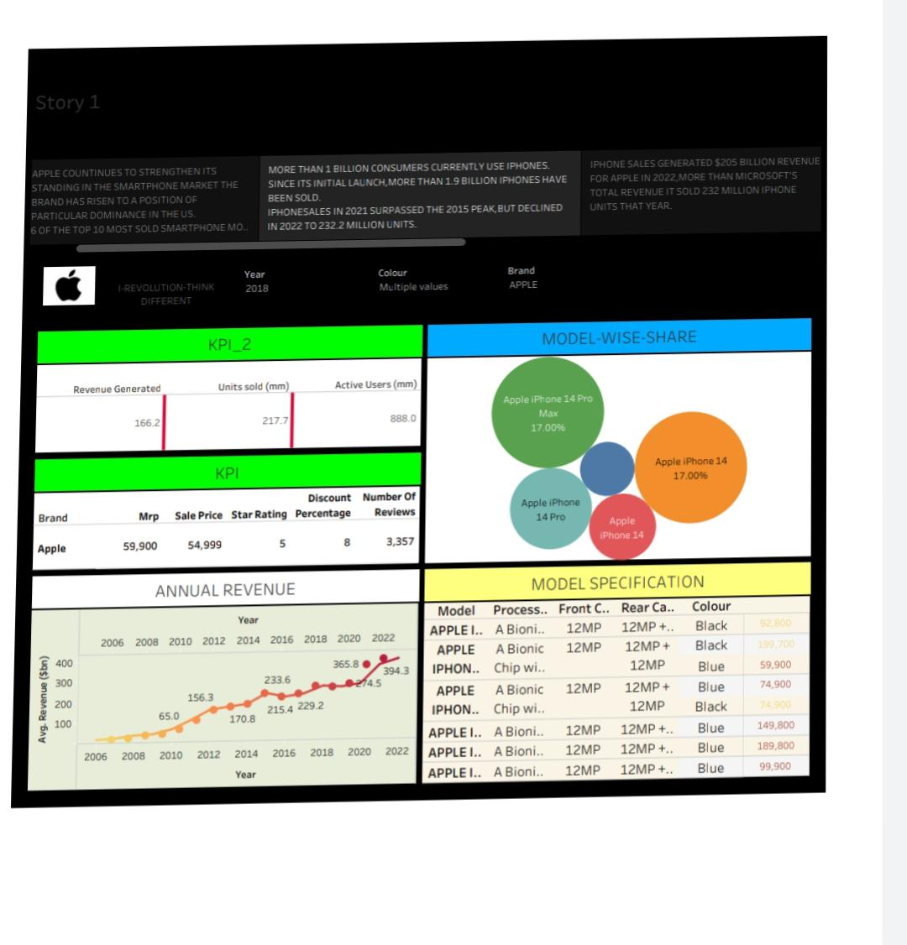

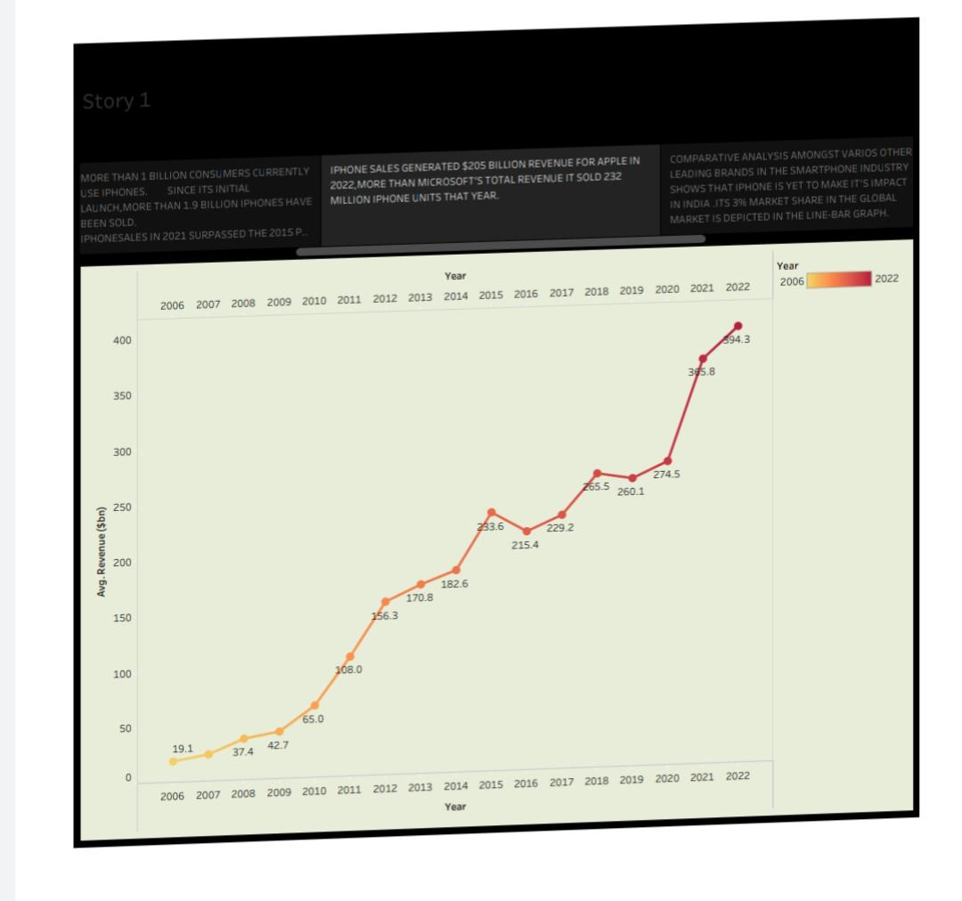

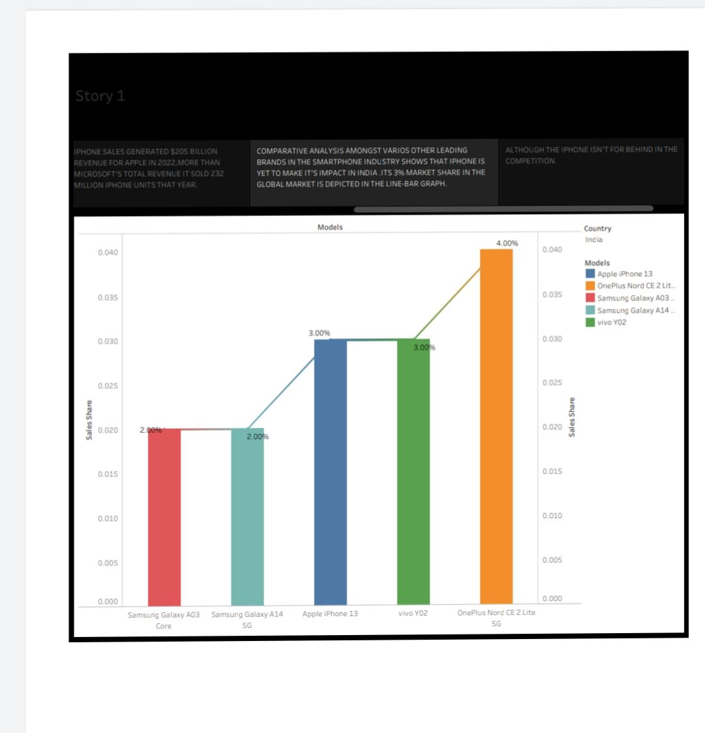

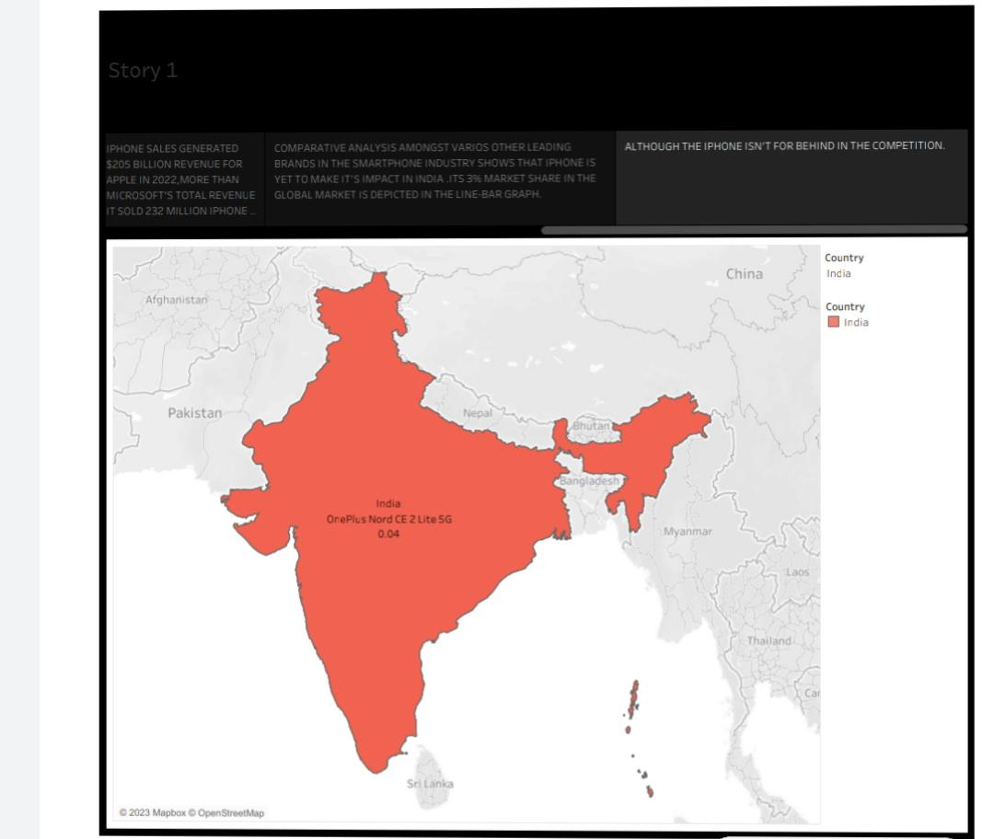

**3.ADVANTAGES AND DISADVANTAGES**

**Advantages:**

**1. User-Friendly Interface: iPhones are known for their intuitive and user-friendly interfaces.**

**2. High-Quality Hardware: Apple typically uses high-quality materials and components for its devices.**

**3. App Ecosystem: The App Store offers a vast selection of apps for various purposes.**

**Disadvantages:**

**1. High Cost: iPhones are often more expensive than many other smartphones on the market.**

**2. Limited Customization: Apple restricts customization options compared to Android devices.**

**3. Closed Ecosystem: Some users may find the closed nature of the Apple ecosystem limiting.**

**5.APPLICATIONS**

**1. Mobile Communication:The iPhone redefined how we communicate by introducing a user-friendly touchscreen interface, iMessage, and FaceTime, making texting and video calls seamless.**

**2. Mobile Internet:iPhones popularized mobile internet access, transforming how people browse the web, check emails, and use social media on the go.**

**3. App Ecosystem:The App Store created a thriving ecosystem for developers, enabling countless applications for productivity, entertainment, health, and more..**

**6.conclutions**

**1. Revolutionized the Smartphone Industry:The original iPhone, released in 2007, revolutionized the smartphone market with its touch screen interface, multi-touch gestures, and sleek design. It set new standards for what a smartphone could be.**

**2. App Ecosystem:The introduction of the App Store in 2008 created a thriving ecosystem of third-party applications, changing the way people use and interact with their devices.**

**3. Design and Build Quality:iPhones are known for their premium design and build quality, setting a high bar for the industry and influencing the design of many other smartphones.**

**7.FUTURE SCOPE**

**1. Advanced Hardware: iPhones will likely continue to push the boundaries of hardware technology, with faster processors, improved cameras, and innovative display technologies.**

**2. 5G and Beyond: As 5G networks become more widespread, iPhones will leverage this technology for faster data speeds, low latency, and new applications like augmented reality (AR) and virtual reality (VR).**

**3. Augmented Reality (AR): Apple is heavily investing in AR technology, and future iPhones are expected to play a significant role in the development and adoption of AR applications in gaming, education, healthcare, and mote.**

**8.APPENDIX**

**1. Introduction of the First iPhone (2007): Apple's original iPhone, released in 2007, marked a significant revolution in the smartphone industry. It combined a mobile phone, an iPod, and an internet communicator in one device, setting the standard for modern smartphones.**

**2. App Store (2008):The launch of the App Store in 2008 allowed developers to create and distribute third-party apps for the iPhone. This ecosystem of apps and games contributed to the iPhone's popularity and changed how we use smartphones.**

**3. iPhone X and Face ID (2017): The iPhone X introduced a new design with a bezel-less OLED display and Face ID facial recognition. This technology reshaped the way we interact with our devices, and the design influenced subsequent iPhone model’s.**